

**QGIS Lab Series**

**GST 101: Introduction to Geospatial Technology**

**Lab 5: Creating Geospatial Data**

**Objective – Digitize Information from a Scanned Hardcopy Source**

**Document Version:** **2014-07-09 (Final)**

**Author:**

Kurt Menke, GISP



**Contents**

1 Introduction 2

2 Objective: Digitize Information from a Scanned Hard Copy Source 2

3 How Best to Use Video Walk Through with this Lab 2

Task 1 Create a New Shapefile 3

Task 2 Transforming Coordinate System of Source Data 6

Task 3 Heads-up Digitizing From Transformed Source Data 15

Task 4 Editing Existing Geospatial Data 18

5 Conclusion 21

6 Discussion Questions 22

7 Challenge Assignment 22

1. Introduction

In this lab, students will learn how to georeference a scanned map. Georeferencing is the process transforming the coordinate system of the scanned map, from the coordinate system produced by the scanning process, into a real world projected coordinate reference system. The student will then learn how to digitize information contained in the scanned map into a shapefile. The first task will be to create the empty shapefile to digitize features into. The student will also learn how to edit existing vector datasets.

This lab will continue to introduce students to the QGIS interface. It is important to learn the concepts in this lab as future courses will require the skills covered in this lab.

This lab includes the following tasks:

* Task 1 – Create a new shapefile.
* Task 2 – Transforming coordinate system of source data.
* Task 3 – Heads-up digitizing from transformed source data.
* Task 4 – Editing existing geospatial data.

1. Objective: Digitize Information from a Scanned Hard Copy Source

While there is a large amount of digital information readily available to users of GIS, there’s still a large amount of information that is not been converted to digital format. For hundreds of year’s hard copy paper maps contained all the geospatial data. Many historic and even newer hard copy maps have never been digitized. It is possible to extract the information from hardcopy sources through process called digitizing. In this lab, you will use heads-up digitizing to digitize parcels in a portion of Albuquerque, New Mexico from a scanned map. This will be accomplished through a five-step digitizing process:

1. Create a shapefile to store the data that will be digitized.
2. Load the scanned map source data into QGIS
3. Georeference the source map
4. Digitize parcels
5. Save
6. How Best to Use Video Walk Through with this Lab

To aid in your completion of this lab, each lab task has an associated video that demonstrates how to complete the task. The intent of these videos is to help you move forward if you become stuck on a step in a task, or you wish to visually see every step required to complete the tasks.

We recommend that you do not watch the videos before you attempt the tasks. The reasoning for this is that while you are learning the software and searching for buttons, menus, etc…, you will better remember where these items are and, perhaps, discover other features along the way. With that being said, please use the videos in the way that will best facilitate your learning and successful completion of this lab.

1. Create a New Shapefile

In Task 3 you will be digitizing parcels from a georeferenced data source. In this first task you will learn how to create the new shapefile you will eventually digitize into.

1. The data for this lab is located at C:\GST101\Lab 5 on the lab machine. Copy this data to a new working directory of your choosing.
2. **Open QGIS Browser 2.2.0.**
3. **Navigate** to the GST 101 Lab 5/Data/New Data folder in the File tree and **select** the **New Data** folder by **clicking** **once** on it so that it is highlighted.
4. **Click** on the **New Shapefile** button at the top of the Browser window



**Figure 1: QGIS Browser New Shapefile button**

1. The **New Vector Layer** window opens. You will choose a geometry type, the coordinate reference system of the new shapefile and add an attribute. **Choose** a type of **‘Polygon’**, and **click** the **Specify CRS** button to open the **Coordinate Reference System Selector (Figure 2)**.

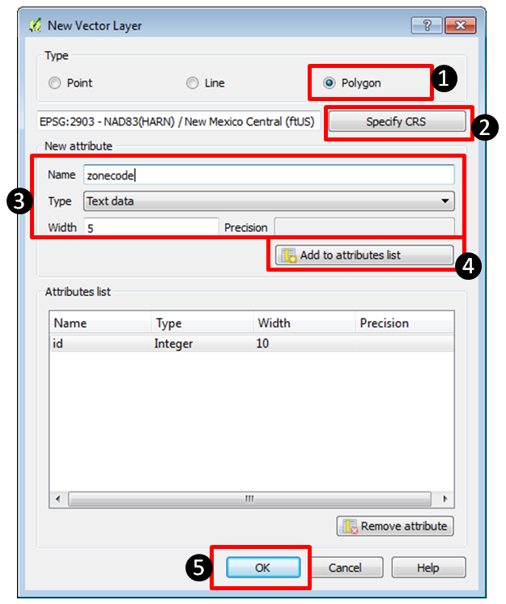

**Figure 2: New Vector Layer window**

The City of Albuquerque, like most municipalities, uses the State Plane Reference System (SPRC) for their data. You’ll use the same CRS for your new shapefile.

1. In the **Coordinate Reference System Selector** type *New Mexico* into the **Filter**. This will limit the list below to just those with New Mexico in their name. These are different SPRC CRS’s for New Mexico. New Mexico has 3 zones and Albuquerque is in the Central zone. **Select** the **NAD83(HARN) / New Mexico Central (ftUS)** with an EPSG code of **2903** (**Figure 3**). Click **OK** once you’ve selected this CRS to be returned to the **New Vector Layer** window.

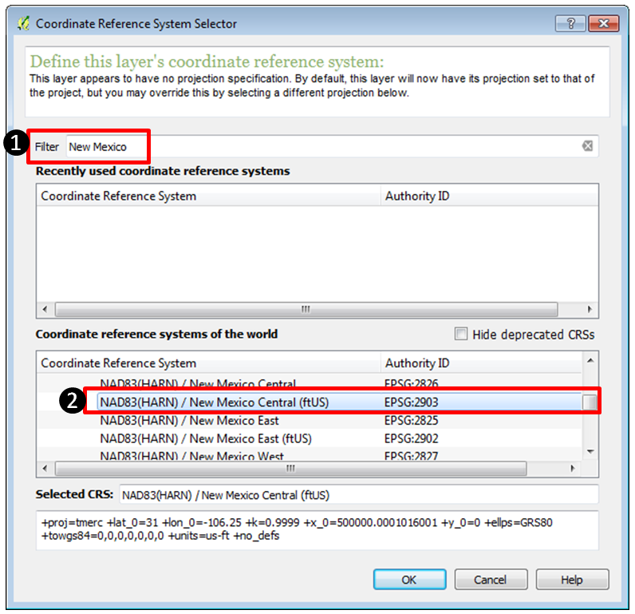

**Figure 3: Browsing for the correct CRS**

While creating your new shapefile you have the option of adding attribute columns. It is possible to add them later, but if you know of some attribute columns you’ll need in the layer it makes the most sense to define them here. You will need an attribute column to hold the zoning code.

1. In the **New attribute** section of the **New Vector Layer** window define a new field with: a name of **zonecode**, as **Text data** with a width of **5 (Figure 2)**. This means the new **zonecode** attribute column will store data as text and will only be able to accommodate five characters of data. Since our longest zoning code is 4 digits this is more than enough.
2. **Click** **Add to attribute list** and you’ll see the new **zonecode** attribute added. The ID attribute is automatically added to every shapefile you create. Click **OK.**
3. The **Save As** window opens. Since you had the **New Data** folder selected when you clicked the **New Shapefile** button it will default to that folder. If it doesn’t just navigate to that folder now. Name the shapefile **parcels.shp** and **click** **Save** to create the shapefile.

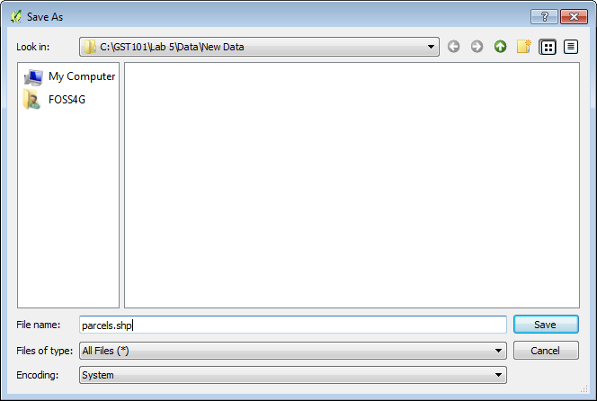

**Figure 4: Save As window**

1. **Click** the **Refresh** button in the upper left hand corner of the **QGIS Browser** window. **Expand** the **New Data folder** and you will see the **parcels.shp** file.
2. **Select** the **parcels.shp** dataset and **click** the **Metadata** tab. You’ll see that it has 0 features and has the Spatial Reference System you specified. The New Mexico Central State Plane zone uses the Mercator projection since it is a north – south oriented zone.

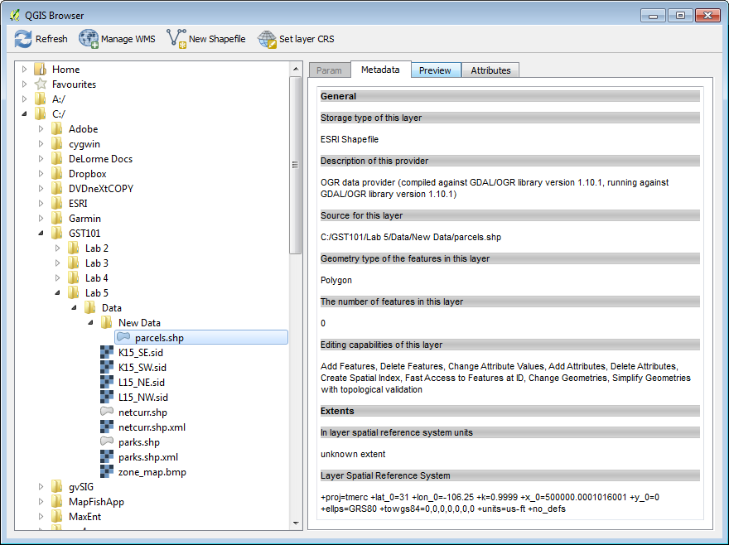

**Figure 5: QGIS Browser with the new parcel shapefile metadata**

1. Transforming Coordinate System of Source Data

Now that you have created an empty shapefile to store the digitized information, you will perform a coordinate transformation (also known as georeferencing) on the source data set so that it is in an Earth-based coordinate system. In this case the coordinate system will match your parcel shapefile (NAD83(HARN) / New Mexico Central (ftUS)).

To perform this task you will be using a Plugin. Plugins are small add-ons to QGIS. Some are created by the core QGIS development team and others are created by third party developers.

1. **Open QGIS Desktop 2.2.0.**
2. **Open QGIS Browser 2.2.0.**
3. **Arrange Browser** and **Desktop** so that you can see both windows simultaneously on your desktop.
4. In **Browser** find the new **parcels** shapefile. **Select** it and **drag** it onto the **map window of QGIS Desktop**. This is another way to add data to Desktop.
5. From the **Menu** bar **choose Project 🡪 Properties**. **Click** the **CRS** tab and **Enable ‘on the fly’ CRS transformation**. **Click** **OK** to save the setting.
6. The project should now have a CRS of EPSG 2903 which is NAD83(HARN) / New Mexico Central (ftUS)). You can **check this by looking at the lower right hand corner of QGIS Desktop and ensuring that EPSG: 2903 is listed**. If not right click on the parcels layer and from the context menu choose **Set project CRS from layer**.
7. **Save** the project to the Lab 5 folder and name it **Lab5.qgs.**
8. From the **menu bar choose Plugins 🡪 Manage and Install Plugins**
9. The Plugins manager will open. Options along the left side allow you to switch between Installed, Not Installed and Settings. The plugin you’ll use is a Core QGIS Plugin called **Georeferencer GDAL**.
10. Since it is a Core plugin it will already be installed. You just need to enable it. **Click** on **Installed plugins** and check the box next to **Georeferencer GDAL (Figure 6)**. **Click Close**.

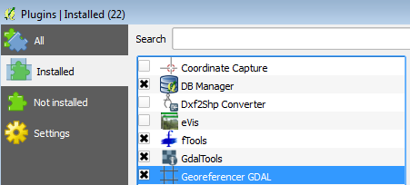

**Figure 6: Plugin Manager**

1. To open the Georeferencer plugin go to the menu bar choose **Raster 🡪 Georeferencer 🡪Georeferencer (Figure 7)**.

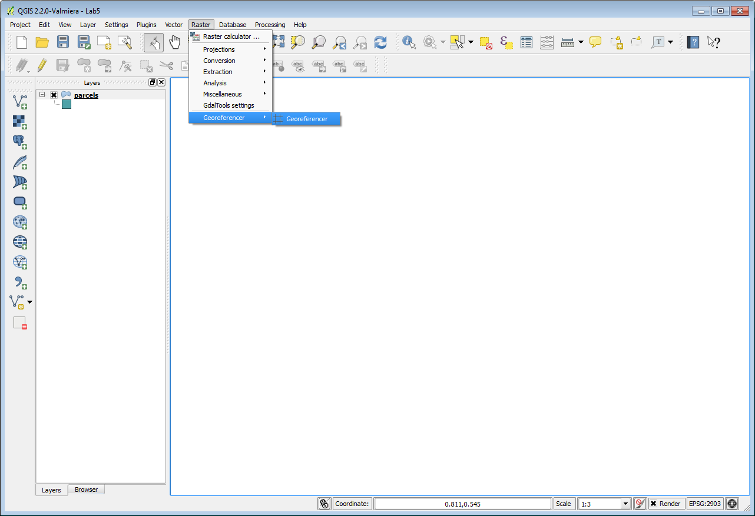

**Figure 7: Opening the Georeferener Plugin**

1. The **Georeferencer** window opens. **Click** the **Open Raster** button at the upper left hand side (**Figure 8**).

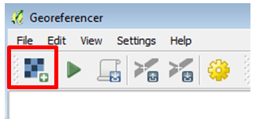

**Figure 8: Open Raster button**

1. **Navigate** to the **Lab 5/Data** folder and **select** the **zone_map.bmp** and click **Open**. **Note**: If the Coordinate Reference System Selector window opens click Cancel to close. This dataset does not yet have an Earth-based coordinate system.

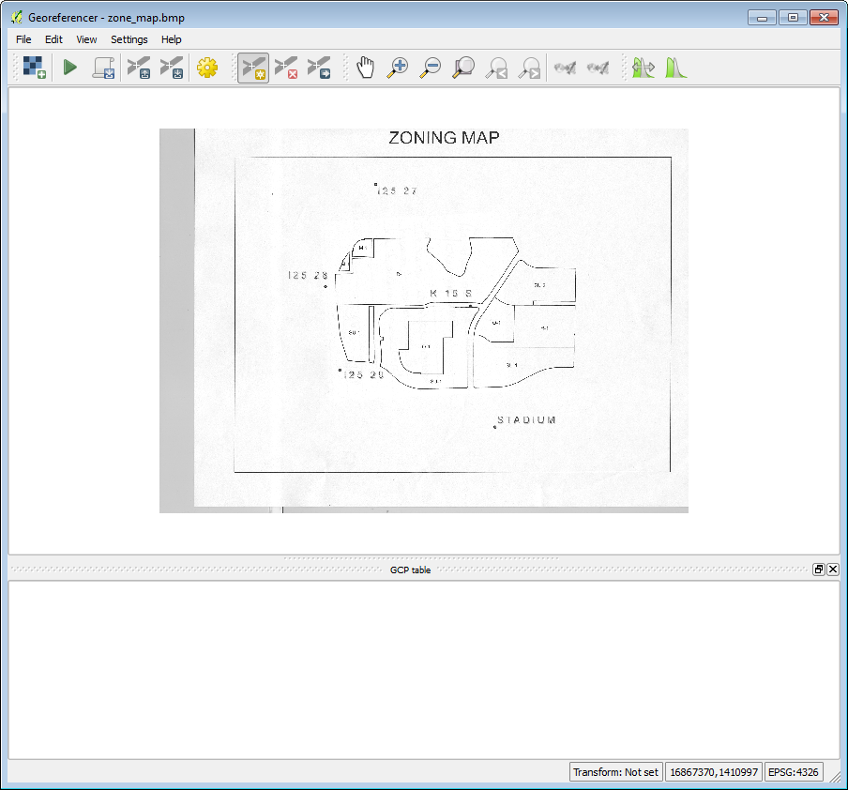

**Figure 9: Georeferencer with source data loaded**

On the map there are 5 points. These are benchmarks maintained by the National Geodetic Survey. To georeference this scanned map you will create control points at these five locations. The plugin will develop a georeferencing equation based off the set of source and target coordinates at these five locations. QGIS will obtain the source coordinates from your mouse click on those points. You will look up the target coordinates for these benchmarks from the NGS website.

1. The NGS website is at <http://www.ngs.noaa.gov/cgi-bin/datasheet.prl> . **Open** the **site.** You will search for each of the benchmarks that appear on the map by searching for each benchmark’s datasheet. You will use the Station Name option to do the search.
2. On the website **click** on the **DATASHEETS** button. Then **click** on the link for **Station Name**.
3. For example, to find the first station, my search would look like **Figure 10**. Enter the **Station name**, pick **New Mexico** as the State and **click** **Submit**. NOTE: the station name is **I25 27** with a capitalized letter i.

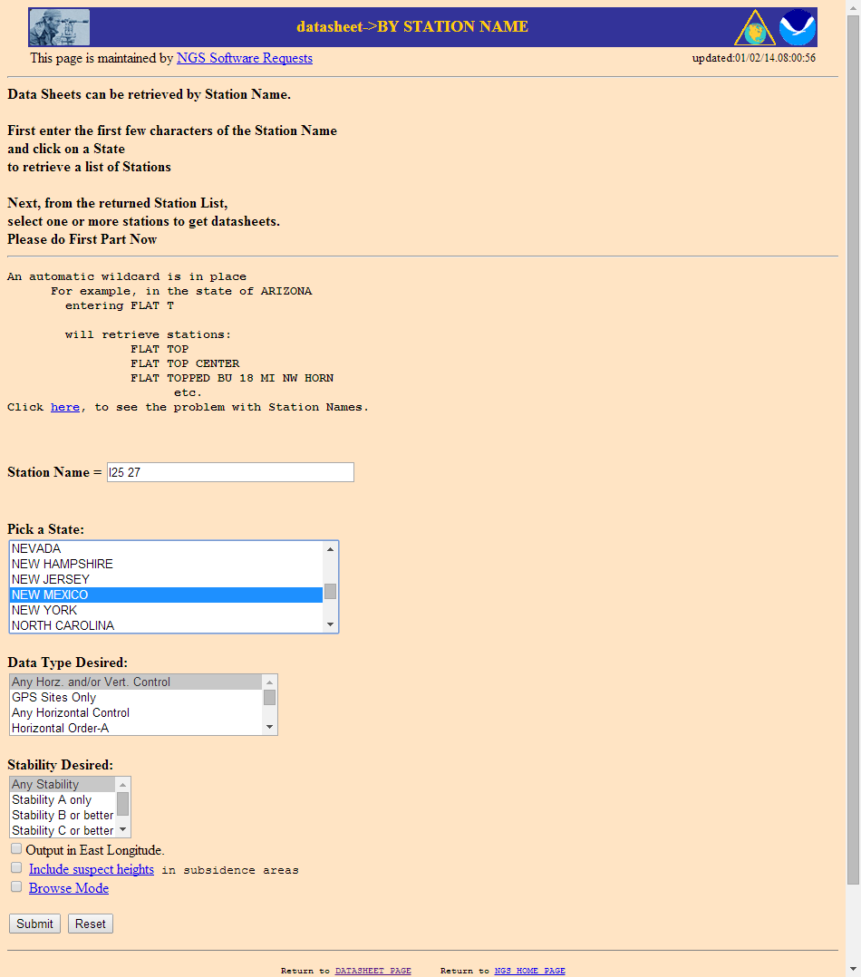

**Figure 10: NGS Datasheet Search**

1. The search should return the page shown in **Figure 11**. **Highlight** the **station name** and **click** the **Get Datasheets** button and you will get something that looks like **Figure 12**.

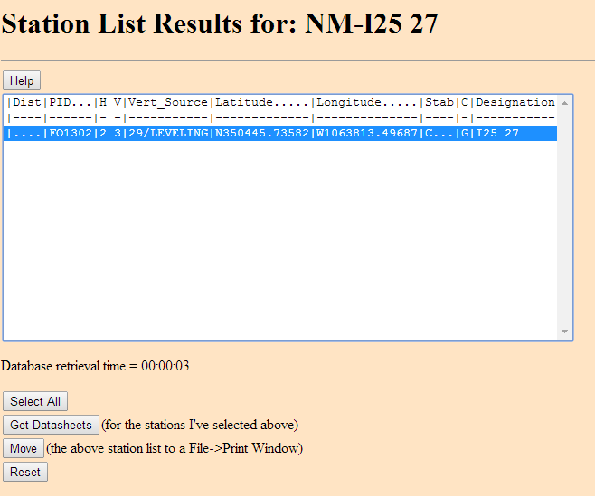

**Figure 11: NGS Datasheet Search Result**

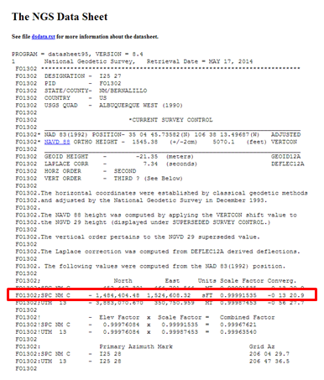

**Figure 12: NGS Datasheet**

1. This is an NGS Data Sheet. It gives measurement parameters for NGS benchmarks located throughout the United States. One piece of information it includes are coordinates for benchmarks in **State Plane feet**. In the **Figure 12**, the SPCS coordinates are circled in red. There are two sets of State Plane coordinates one in meters and one in feet. Be sure to use the set in feet. **Note**: there is a dash before the northing. It is not a negative number.
2. Find each benchmarks data sheet and fill in the coordinates below. The coordinates for the first station have been entered already.

|  |  |  |
| --- | --- | --- |
| **Benchmark** | **Northing** | **Easting** |
| I25 27 | 1,484,404.48 | 1,524,608.32 |
|  |  |  |
|  |  |  |
|  |  |  |
|  |  |  |

1. The next step is to inter the control points in the Georeferencer. **Click** on the **Add point** button. 
2. **Click** on point ***I25 27***. (It is important to be precise and click directly on the point. The accuracy of your transformation depends on precisely locating the points. If you want to redo a control point click the  **Delete point** button and **click** on the point to delete.) The **Enter map coordinates** window opens. **Enter** the **easting** and **northing** State Plane Coordinates into the two boxes. Make sure you enter them correctly. The **Enter map coordinates** window is asking for the easting first and the NGS site listed the northing first (**Figure 13**). Click **OK** and a red control point will appear on the map. The ‘to’ and ‘from’ coordinates will display in a table at the bottom of the window.

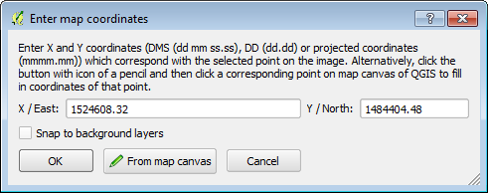

**Figure 13: Adding a Control Point for ‘I25 27’**

1. **Repeat** this procedure for points **‘I25 28’, I25 29’, K 15 S’** and **‘STADIUM’**. After the 5 control points have been entered your **Georeferencer** window should look like **Figure 14**.

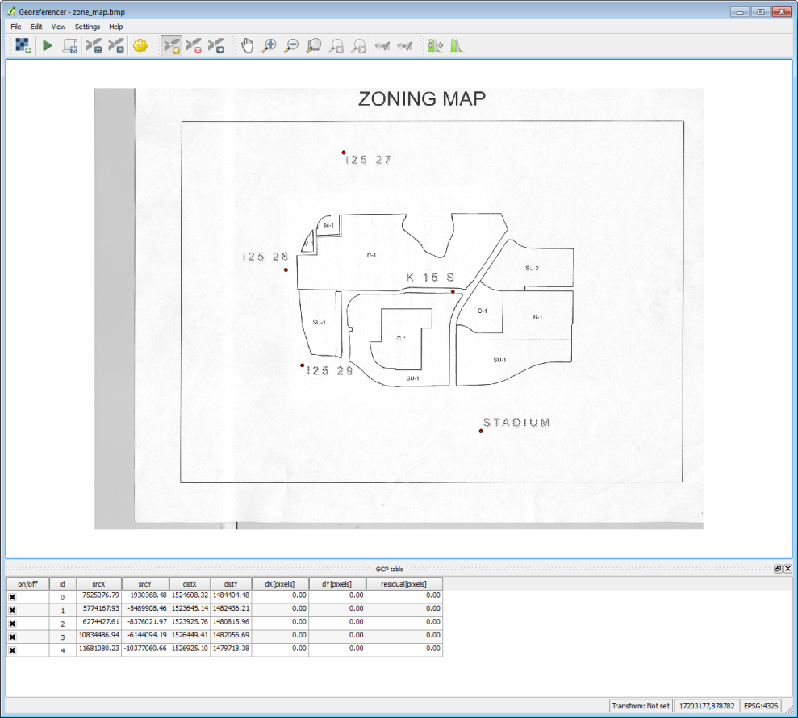

**Figure 14: All control points entered**

1. To perform the transformation **click** the **Start georeferencing**  button.
2. The **Transformation settings** window will open (**Figure 15**). If beforehand you get a message saying **‘Please set transformation’** type click **OK**.
   1. In the **Transformation window** choose the **Polynomial 1** as the **Transformation type**.
   2. Choose **Nearest neighbor** as the **Resampling method**. This is the standard raster resampling method for discrete data such as a scanned map.
   3. **Click** the browse button to the right of **Output raster**. **Navigate** to your **Lab 5/Data/New Data** folder and name the file **zone_map_modified_spcs.tif**.
   4. **Click** the browse button to the right of **Target SRS**. Type **2903** into the **Filter** and then double click the **NAD83(HARN)/N… EPSG:2903** CRS to make it the **Selected CRS (Figure 16)**.
   5. **Click ‘Load in QGIS when done**’.
   6. **Click OK.**

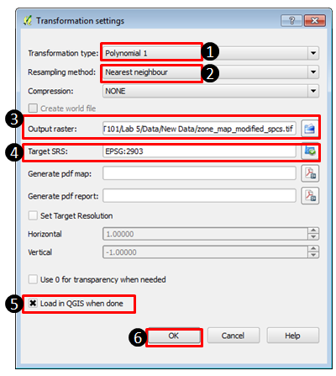

**Figure 15: Transformation Settings**

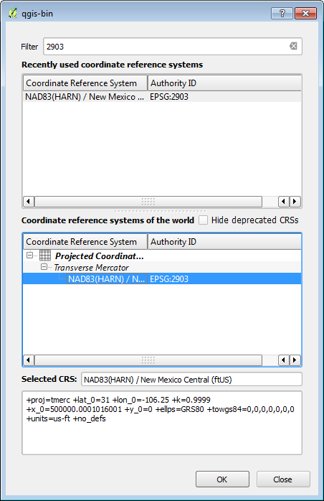

**Figure 16: Selecting the CRS of the Output Raster**

1. **Close** the **Georeferencer** and **Save GCP points**.
2. **Right click** on the zone_map_modified.tif and choose **Zoom to layer extent** to see the georeferenced image.
3. Using the **Add vector data button** add the **netcurr.shp** shapefile in the **Lab 5/Data** folder to QGIS. This is a shapefile representing city streets produced by the City of Albuquerque. If the transformation was done correctly, the streets will line up with the georeferenced parcel map image (**Figure 17**). **Save** your map file.

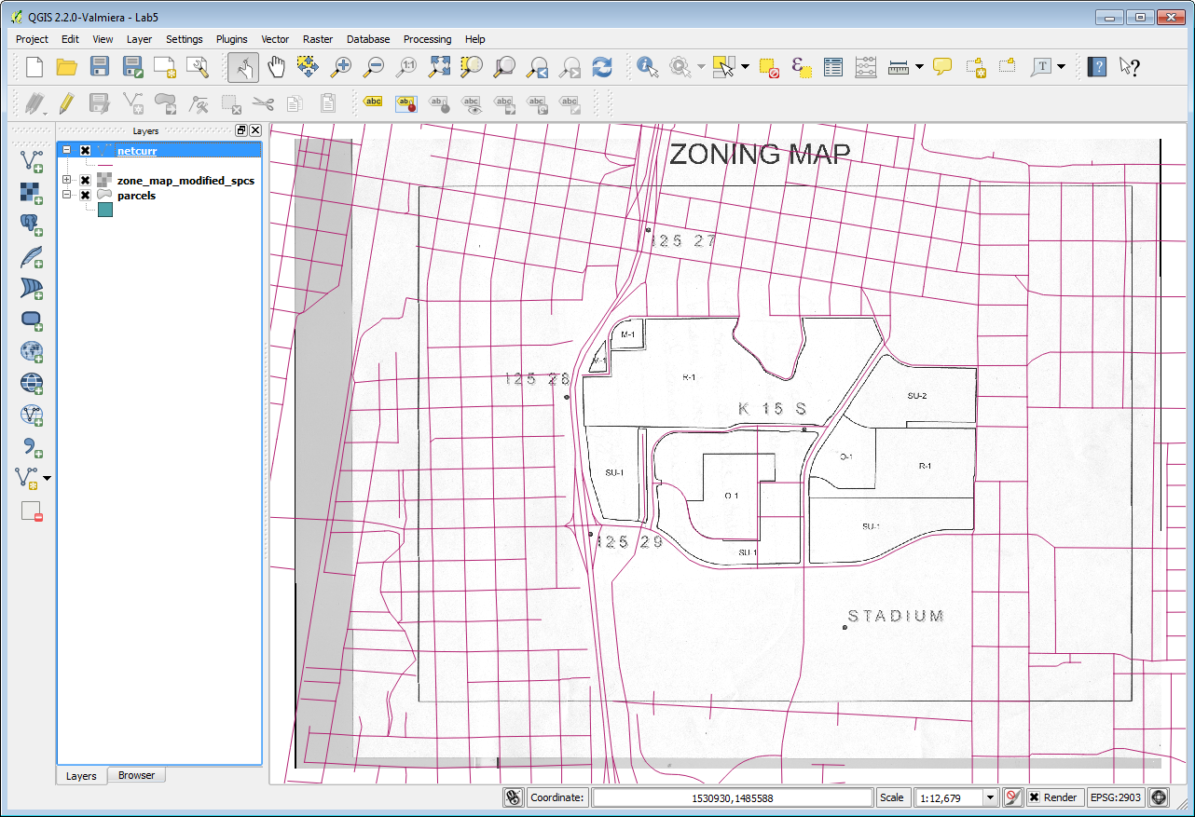

**Figure 17: Georeferenced parcel map image**

1. Heads-up Digitizing From Transformed Source Data

Now you will digitize the parcels off the georeferenced image into the parcels shapefile.

1. **Drag** the **parcels** layer above the **zone_map_modified_spcs** layer in the Table of Contents. Right **click** on parcels and choose **Toggle editing**. This puts the parcels layer into edit mode. Notice that a pencil appears next to the layer in the Table of Contents telling you that layer is in edit mode. Only one layer can be edited at a time. **Turn off** the **streets** layer.
2. Using the **Zoom in** tool, drag a box around the **M-1** parcels in the northwest corner of the image. You’ll digitize these first. There is an **Editing toolbar** for editing vector datasets (**Figure 18**). If you don’t see that go to the menu bar to View 🡪 Toolbars and turn it on. The tools available change slightly depending on the geometry of the data you are editing (polygon, line, point).When editing a polygon layer you will have a tool for adding polygon features.



**Figure 18: Editing toolbar**

1. **Click** on the **Add Feature** tool . Your cursor will change to an editing cursor that looks like a set of cross hairs.
2. Polygons are constructed of a series of nodes which define their shape. Here you’ll trace the outline of the first parcel clicking to create each node on the polygons boundary. Put your cursor over a corner of one of the polygons. **Left click** to **add** the first point, left click again to add the second, and continue to click around the perimeter of the parcel. After you have added the final node **finish the polygon with a right click**.
3. An **Attributes** window will open asking you to populate the two attributes for this layer: id and zonecode. Give the parcel an **id** of **0** and the **zonecode** is **M-1** (**Figure 19**). Each parcel feature will receive a unique id starting here with zero. The next parcel you digitize will be id 1, the one after that id 2 etc. **Click OK**.

If you want to delete the polygon you’ve just added click the **Current Edits** tool dropdown menu  and choose **Roll Back Edits** to undo your polygon.

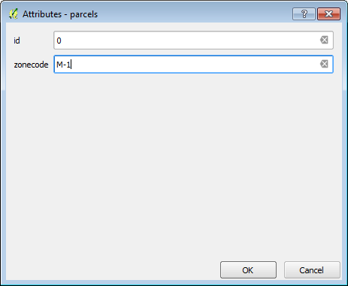

**Figure 19: Attributes window**

1. Adding single isolated polygons is pretty straightforward. **Zoom back to the extent of the image.** You can do this by **right clicking** on the source data raster and choose **Zoom to layer extent** or by clicking the **Zoom last ** button.
2. Find the big parcel in the south central area. There is a parcel with zoning code **SU-1** that wraps around **O-1**. Zoom to that area.
3. **Open** the **Layer properties** 🡪 **Style** tab for the parcels layer and set the **Layer transparency** to **50%** so that you can see the source data underneath your parcels.
4. **Digitize** the outer boundary of the **SU-1** parcel ignoring the O-1 parcel for the moment. **Fill in the attributes** when prompted. The SU-1 polygon will be a ring when completed but for now it covers the O-1 parcel.
5. To finish SU-1 you will use a tool on the **Advanced Editing** toolbar. To turn that on go to the menu bar and choose **View 🡪 Toolbars**. Turn on the tool bar and dock it where you’d like. All toolbars in the QGIS interface can be moved by grabbing the stippled left side and dragging them to different parts of the interface.
6. Now you’ll use the **Add Ring** tool . **Select** it and **click** around the perimeter of the **O-1 parcel**. Right click to finish. This creates a ring polygon (**Figure 20**).

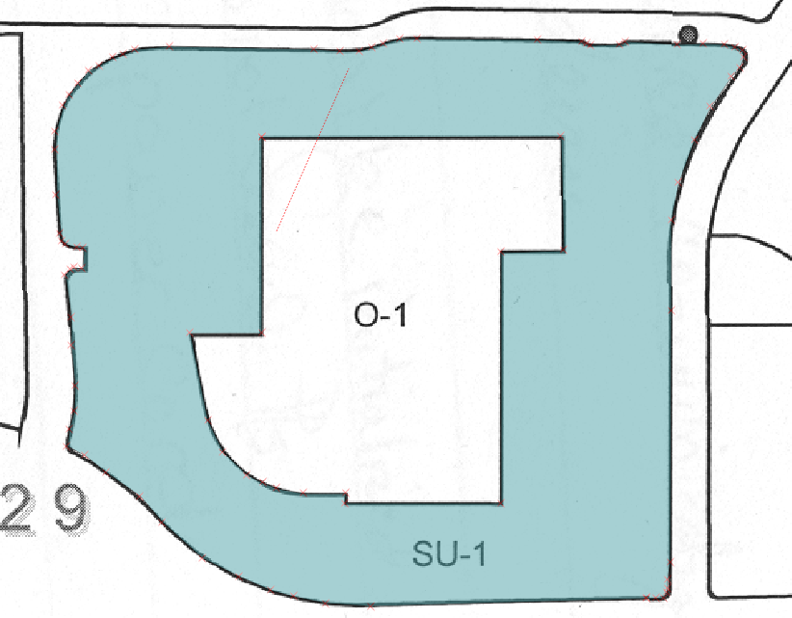

**Figure 20: SU-1 Ring Polygon**

1. Now you will digitize O-1. To do so first you will set your snapping environment. Go to the menu bar and **choose Settings 🡪 Snapping options**. This is a window that lets you configure what layers you can snap to while editing and set the snapping tolerance. The **Mode** lets you control what portions of a feature are being snapped to. **To** **Vertex** will snap to vertices, **To Segment** will snap to any part of another layers edge, and **To Vertex** **and Segment** will snap to both. The **Tolerance** determines how close your cursor needs to be to another layer before it snaps to it. It can be set in screen pixels or map units. In our case map units are feet.
2. **Uncheck netcurr** since we won’t want to snap our parcels to that layer. Setthe **tolerance** for **parcels** to **50 map units** and choose a **Mode** of **to vertex (Figure 21)**. The map units are feet so when you get within 50 feet of a node (aka vertex) you will snap to it. This allows you to be much more precise than you could otherwise. **Click OK**.

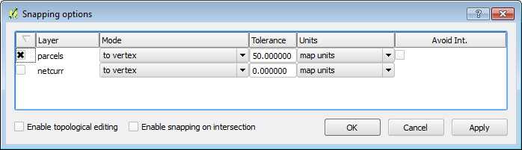

**Figure 21: Final Map Extent**

1. To Digitize O-1 you'll use a tool that is part of the **Digitizing Tools Plugin**. First open the **Plugin Manager** and search for *'Digitizing Tools*' in the **All** category. Select the Plugin and click the **Install Plugin** button. You should get the message **Plugin Installed Successfully**. Once it has been installed switch to the Installed plugins and make sure the **Digitizing Tools** plugin is enabled. The plugin is a toolbar.



1. Dock the toolbar, and select the **Fill ring with a new feature (interactive)** tool . **Left** **click** on one of the vertices that defines the inner SU-1 polygon ring. You will immediately be prompted to **enter the attributes** for the new O-1 polygon. **Click** **OK** when done and the new polygon will appear. It automatically fills the space leaving no gaps.
2. Use the **Identify tool**  to click on O-1 and SU-1 and verify that they are digitized correctly.

**NOTE:** If you end up needing to move one or two misplaced vertices on a finished polygon you can do that. Use the **Select Single Feature** tool  to select the polygon, then use the **Node Tool ** to select the individual node and move it.

If snapping is interfering with digitizing a parcel polygon you can go to **Settings 🡪 Snapping options** at any time (even during digitizing) and turn snapping off until you need it again.

1. **Finish digitizing the polygons**. Anytime you have a parcel that shares a boundary with another, use snapping to make sure you create two parcels without a gap in between. Go back into **Settings** **🡪 Snapping options** and check the box under **Avoid Int.** to the right of Units. This enables **Topological editing**. When digitizing a shared boundary with this option checked you can begin with one of the vertices at one end of the shared boundary. Then continue digitizing the boundary of the new polygon and end at a vertex at the other end of the shared boundary. The shared boundary will be created automatically eliminating digitizing errors.

Remember you can adjust the snapping tolerance and what features are being snapped to Vertex, Segment and Vertex and Segment.

1. When finished, click the **Toggle Editing**  button to exit out of editing mode. You will be prompted to save your changes. **Click Yes**.
2. **Turn off the zone_map_modified_spcs raster**. You’re done with that now. It was an intermediate step necessary to get the parcel boundaries digitized.
3. **Save your project**.
4. Editing Existing Geospatial Data

Now that you have digitized data into the empty shapefile you created you will learn how to modify existing shapefiles.

1. You will add an aerial photograph raster. **Click** the **Add Raster Layer** button. **Set the filter** to **Multi-resolution Seamless Image Database (*.sid, *.SID)** . Add all four SID images.
2. **Drag** the **parcels** layer **above** the **image** in the Table of Contents.
3. **Click** the **Add Vector Layer** button and add the **parks.shp** shapefile.
4. **Drag** the **parks** layer **above** the **raster imagery** in the Table of Contents.
5. **Turn** **off** the **parcels** layer.
6. **Open** the **Layer properties** 🡪 **Style** tab for the **parks** layer and set the **Layer transparency** to **50%** so that you can see the source data underneath your parcels.
7. **Zoom into**  the area highlighted **in Figure 22**.

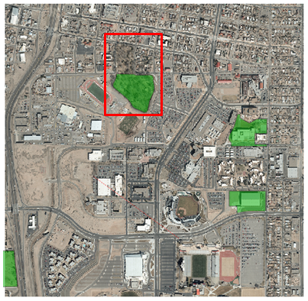

**Figure 22: Parks and Aerial Photography**

1. This park polygon is incomplete. You will add the missing piece. **Right click** on parks and **Toggle editing**.
2. **Set** your **Snapping** **Options** so that you are only snapping to **park vertices** with a **tolerance of 25 feet (map units)**.
3. Using the **Advanced editing** toolbar click on the **Reshape Features** button . This tool allows you to add to an existing feature. You must add your first vertex within the boundary of the existing polygon and add your last vertex within the boundary of the polygon that you are adding to. The other vertices you add can be outside. When you finish the extra area will be added to the existing feature.
4. **Click** **within the park boundary** then **click on the corner vertex in the northwest corner**. **Continue to trace the park boundary** using the outside of the perimeter sidewalk as the border. As you’re working your way back south on the eastern side snap to the existing vertex on the northeast side. Continue into the park boundary adding one more vertex to the interior of the existing park. **Right click to finish**.
5. **Toggle off editing. Click Yes** to save your changes to the parks layer**.**
6. Now you will make an edit to a line layer. **Turn on** the **netcurr** layer.
7. Zoom into the location highlighted in **Figure 23**.

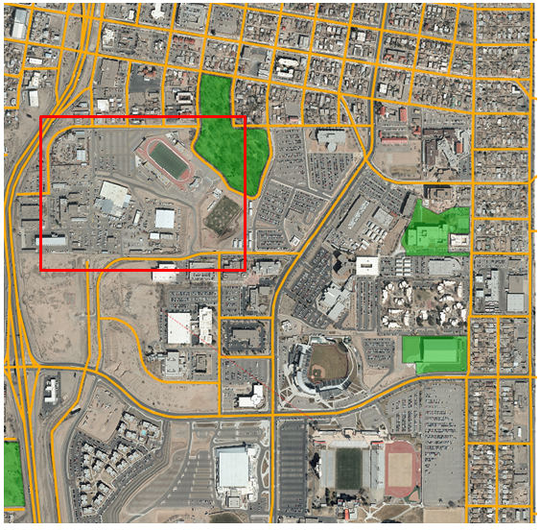

**Figure 23: Roads, Parks and Aerial Photography**

1. You will digitize the missing main road, shown in yellow in **Figure 24**.

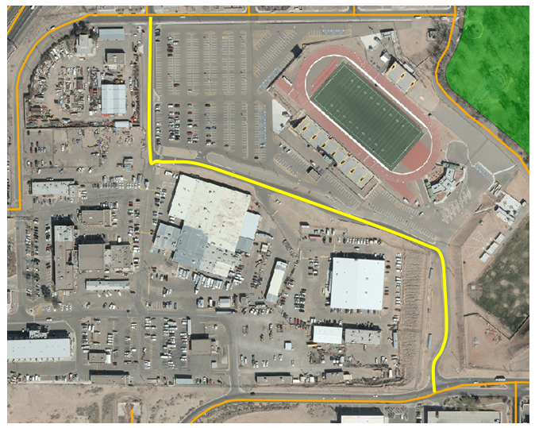

**Figure 24: Missing Road**

1. **Toggle on editing** for **netcurr.**
2. **Set** your **Snapping options** so that only **netcurr** is being snapped to, with a **Mode** of **To Vertex** and a **Tolerance** of **20 feet**.
3. Usingthe **Add Feature** tool on the **Editing** toolbar **,**  **digitize** the new road making sure to snap to the roads at the northern and southern ends. Use the centerline of the road while digitizing.
4. There are many attributes for this layer. You will just enter a few. Enter the **STREETNAME** as **Park**, the **STREETDESI** as **Place**, the **STREETQUAD** as **SE** and the **COMMENTS** as **Lab 5**. **Click OK**.
5. **Toggle off editing** and **Save**.

5 Conclusion

In this lab, you have successfully digitized information using the five-step digitizing process. Additionally, you have recreated the original source data (scanned as a raster) in the vector format. Digitizing can be a time-consuming and tedious process, but can yield useful geographic information.

.

.

6 Discussion Questions

1. What can contribute to errors in the georeferencing process?
2. What other vector geometries (point/line/polygon) could be appropriate for digitizing a road? In which instances would you use one vector geometry type over another?
3. When you created the parcels shapefile you added a text field to hold the zoning codes. What are the possible field types? Explain what each field type contains, and provide an example of a valid entry in the field.
4. Aerial photography has a lot of information in it. What other features could you digitize off of the imagery in this lab? Explain what vector geometry you would use for each.

7 Challenge Assignment

You have successfully created the parcel data from a scanned map. You have also fixed the parks and roads data in this part of town. There are some sports facilities visible: two football fields and a baseball field. Create a new layer and digitize those three facilities (include the grassy field areas at a minimum).

Create a simple page sized color map composition using the QGIS Desktop Print Composer showing your results. Show the parcels, sports facilities, parks, roads and aerial photography. Use Categorized styling to give a unique color to each zone code in the parcel data. Include:

* Title
* Legend (be sure to rename your layers so that the legend will be meaningful.)
* Date and Data Sources

You can credit the data sources as the City of Albuquerque and yourself. If you need to refresh your memory, review GST 101 Lab 4.